Coding Tips & Tricks

1. Control H - To search files in entire IDE

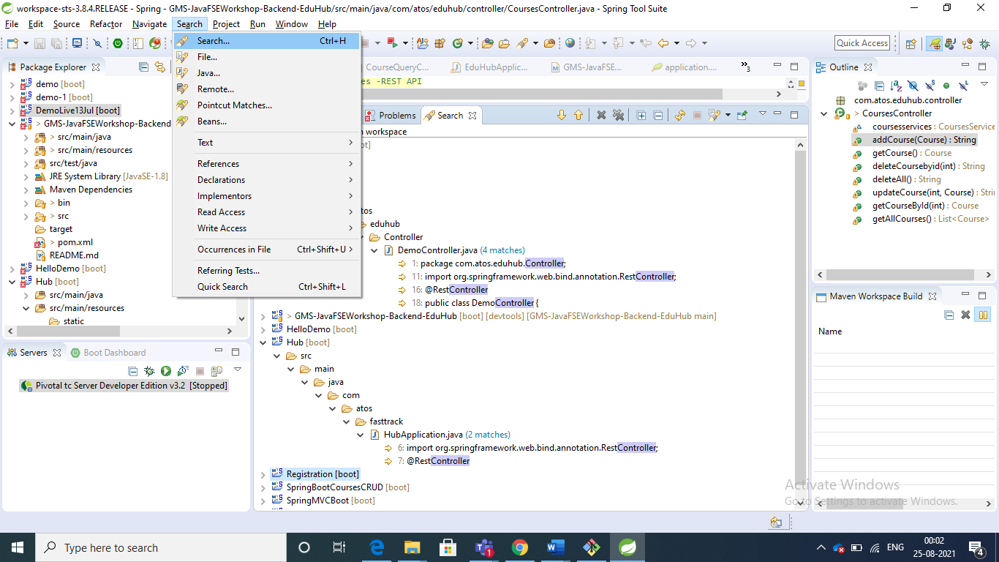

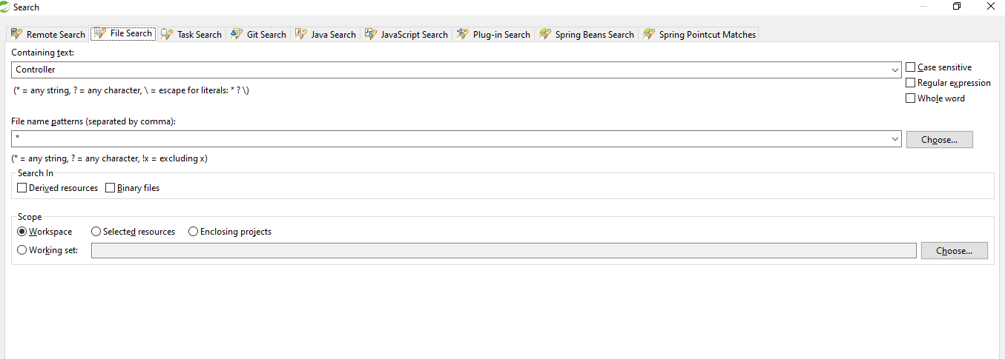

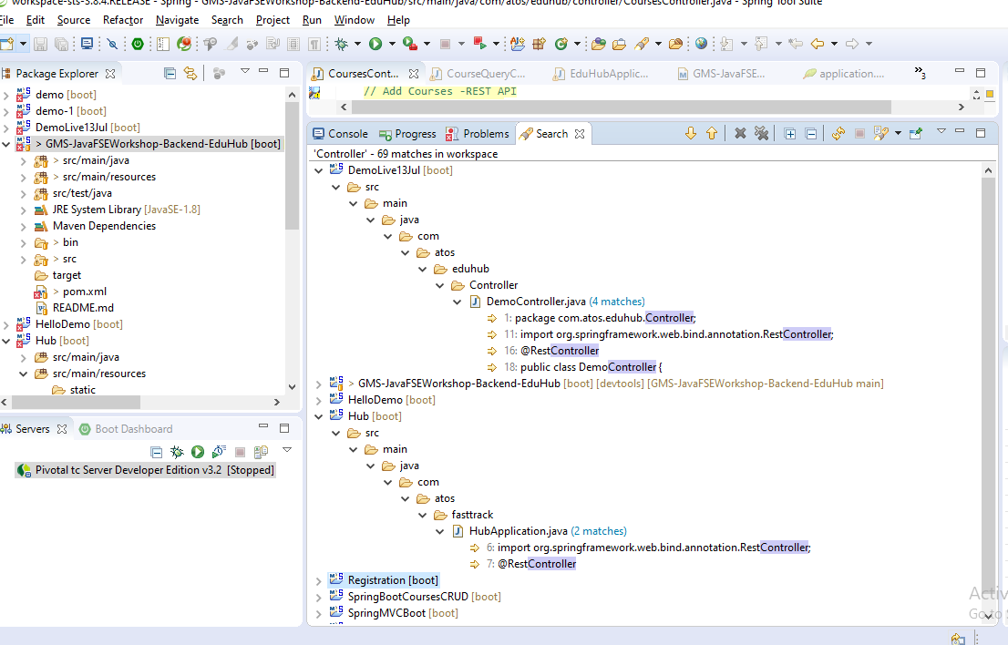

1. Control +Shift +R

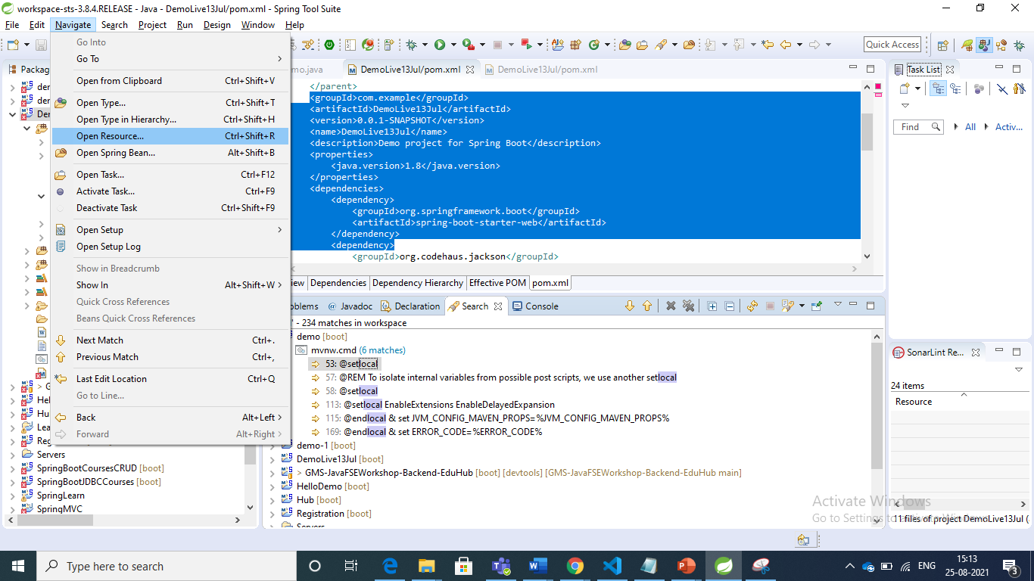

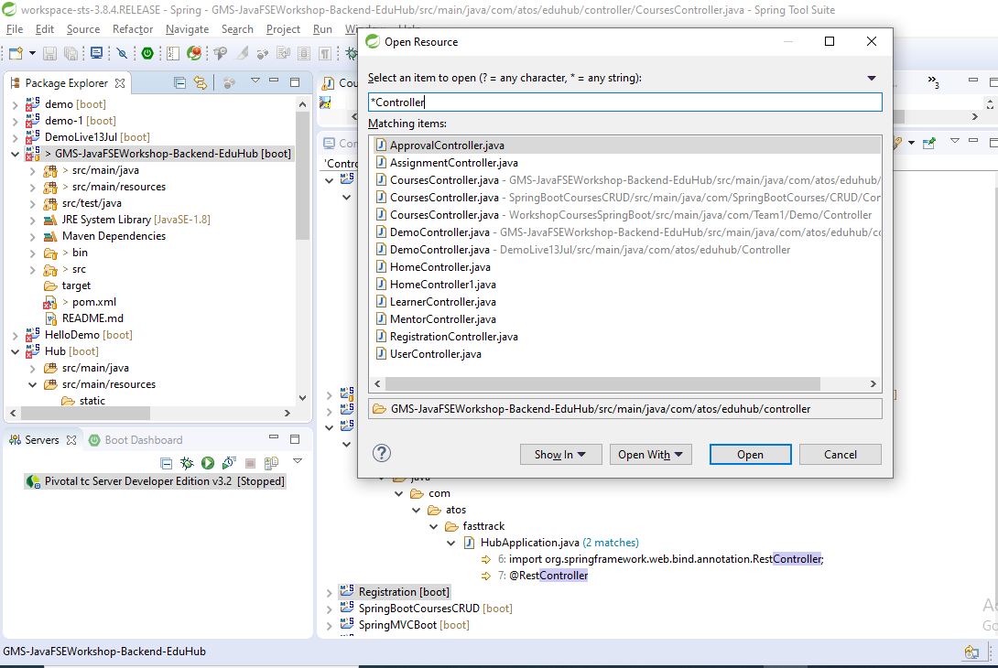

Few thing useful, recommendation formatting tool by market players

Manual codereview has been replaced by tool review. Functional/business and design patterns gets focus

1. **F3** or **Ctrl+Left click**: goes to declaration of element
2. **LOCATING A MATCHING BRACKET**

**Searching a for beginning/back block of code--🡪**

Select an opening or closing bracket and press Ctrl+Shift+P to find its matching bracket.

1. By default automatic formatting and cleanup is disabled. To enable it, do the following:
2. Go to **Window > Preferences > Java > Editor > Save Actions**.
3. Select **Perform the selected actions on save**.
4. Select **Format Source code**. Make sure Format all lines is selected. [Below](http://www.eclipseonetips.com/2009/12/13/automatically-format-and-cleanup-code-every-time-you-save/#scm-diffs) I discuss when to use the other option.
5. Make sure **Organize imports** is selected.
6. Select **Additional actions**.
7. Click Ok, edit some code, save it and watch Eclipse format it automatically.

Here’s what the settings should look like.

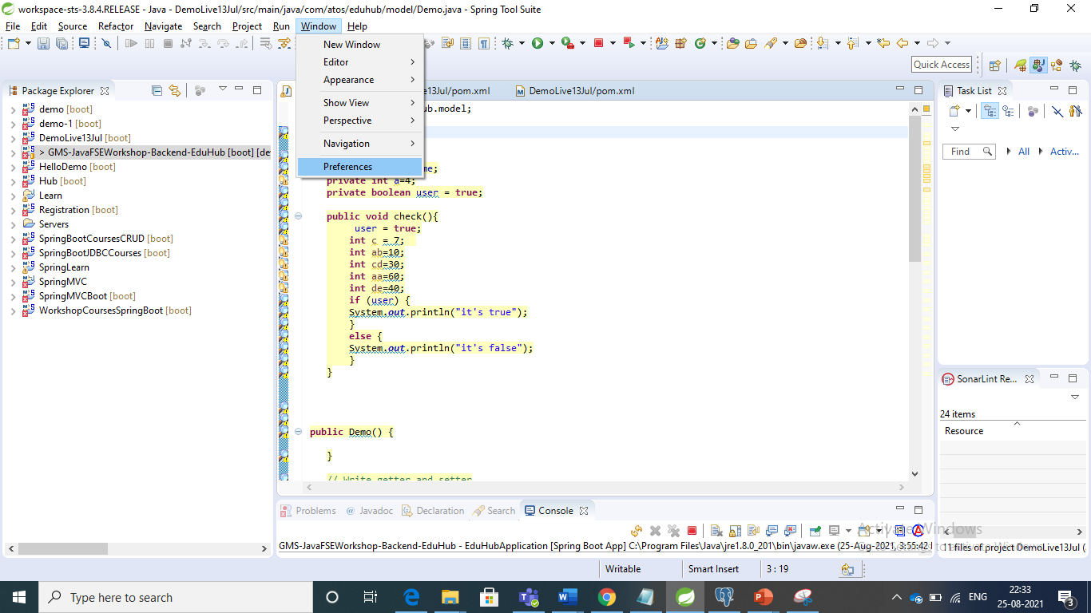

**[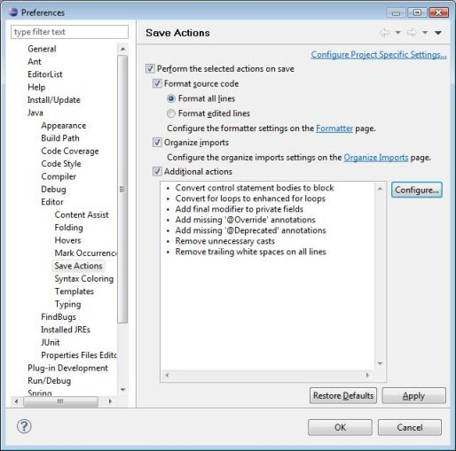](http://www.eclipseonetips.com/wp-content/uploads/2009/12/save-actions-preferences-smaller.jpg)**

1. **Formatter options**

Window>Preferences>Java>Code Style>Formatter.

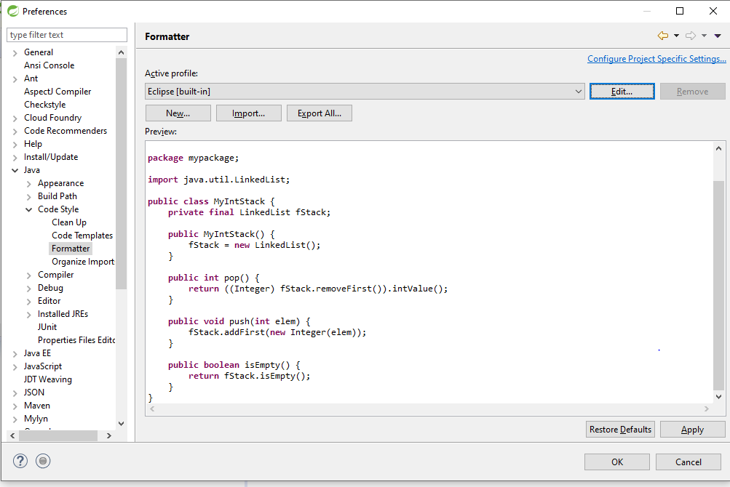

**Recommended standards –**

**Indentation**

**Brackets**

**Code style**

**import**

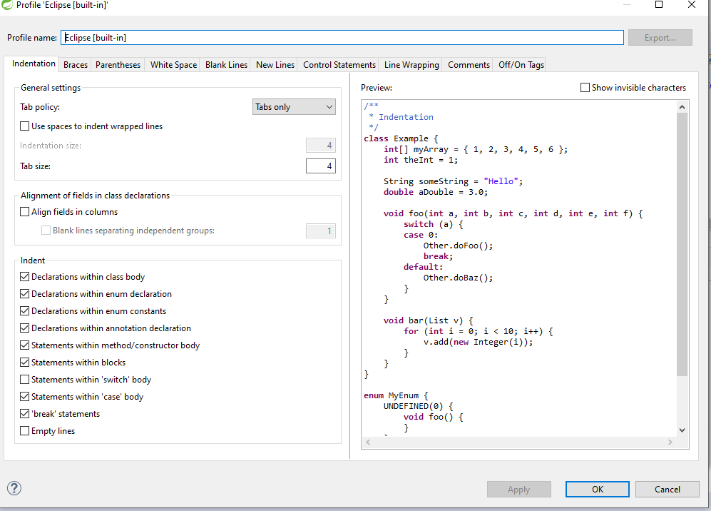

Refer here - http://www.eclipseonetips.com/2009/12/13/automatically-format-and-cleanup-code-every-time-you-save/

1. Check Style Option
2. Install CheckStyle from MarketPlace

Right click on the project and check option for Checkstyling

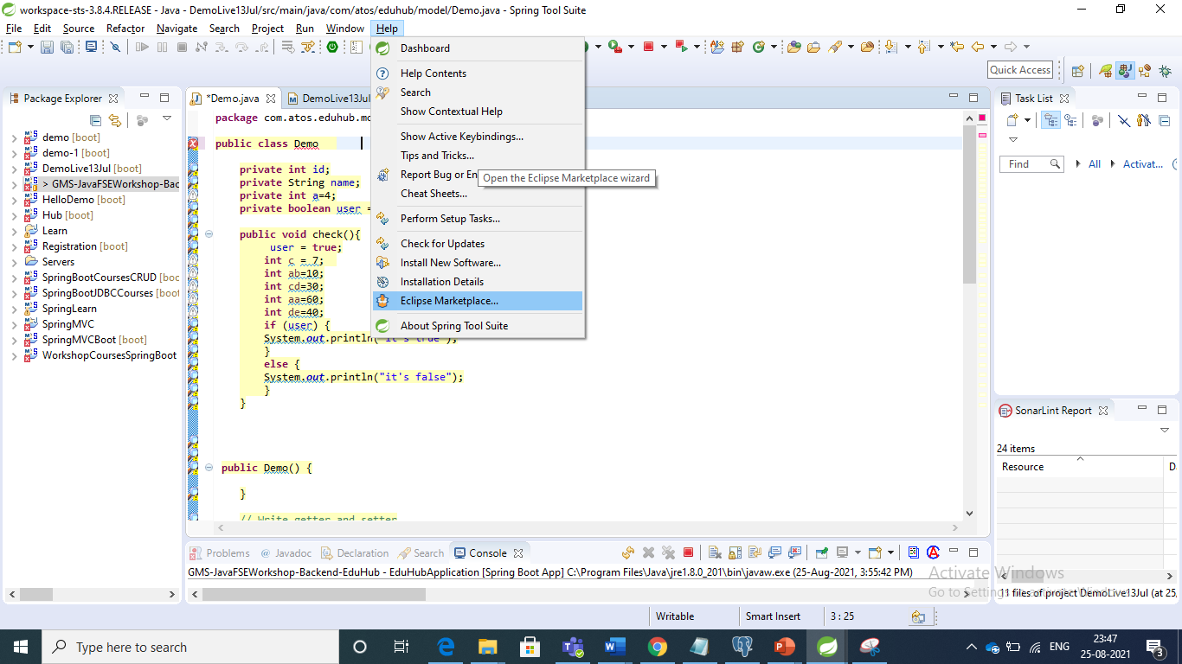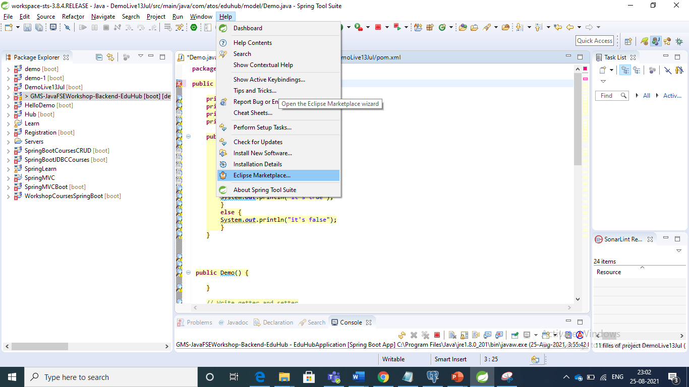

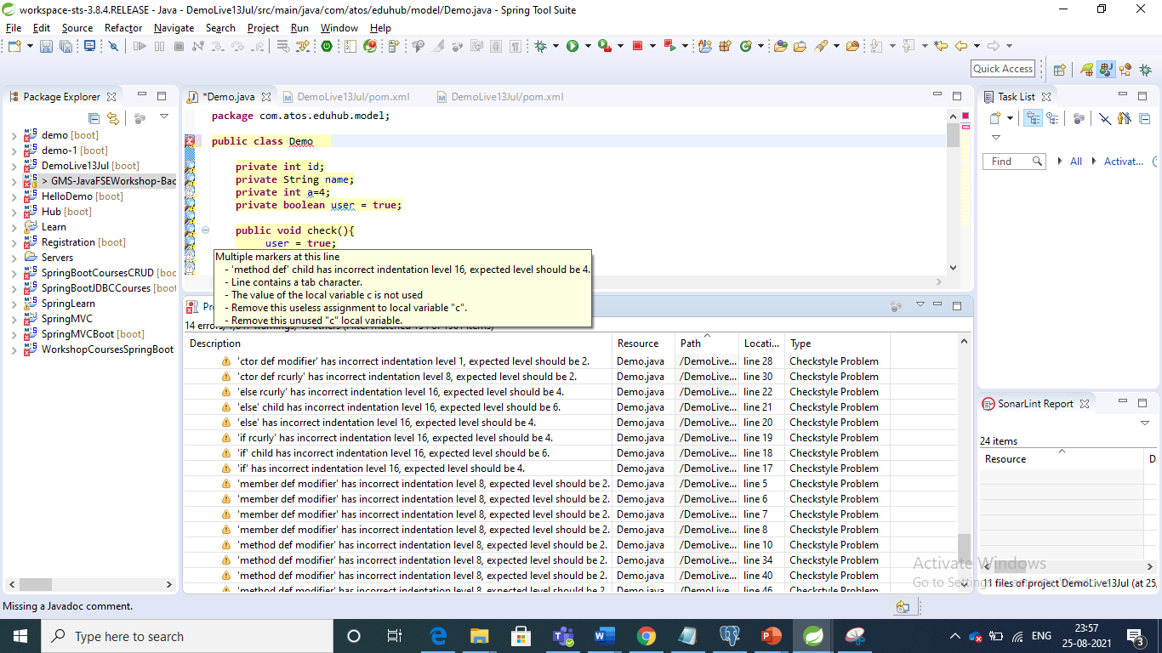

SonarLint

1. Install Sonarlint from MarketPlace

Right click on the project and check option for Sonarlint

Differences - 🡪 check that

Theory

Sonarlint is a IDE exenstion that helps to detect and fix quality issues as you write code in Java, JavaScript, HTML, VS Code

Spelling error

Highlights bugs, flags their priorities and provide guidance to fix them

